**Scrapy Project Setup Guide**

Scrapy is recommended to be run inside a Python virtual environment. Anaconda makes it easier to create and manage several different virtual environments.

Pycharm is the recommended IDE to run the projects on.

Please follow below steps to run a scrapy project inside Virtual Environment:

1. Install Anaconda.
2. Download the Environment file : https://github.com/avinashknagar/newsScrape/blob/master/environment.yml
3. Inside Anaconda Navigator, Open Environments and Import a new Environment as below.

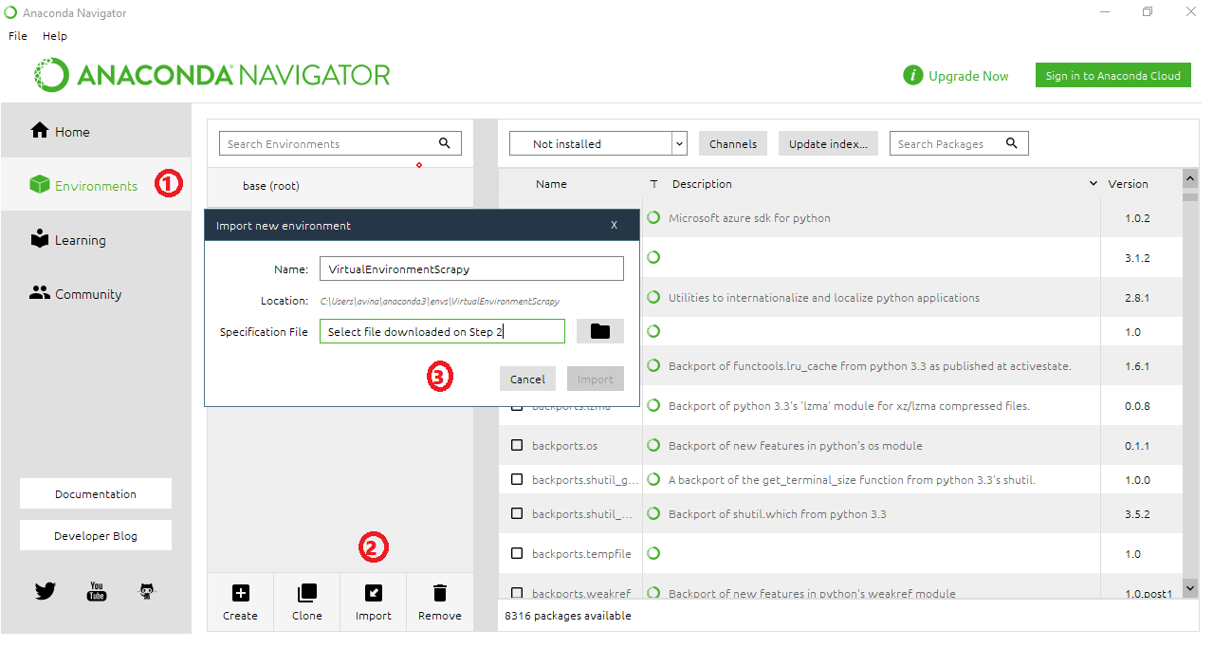

1. Install Pycharm.
2. Download and Import Project in Pycharm:

<https://github.com/avinashknagar/newsScrape/tree/master/newsCrawl>

1. Set Project Interpreter to created Anaconda Virtual Environment as below:Go to Pycharm -> Preferences -> Project -> Python Interpreter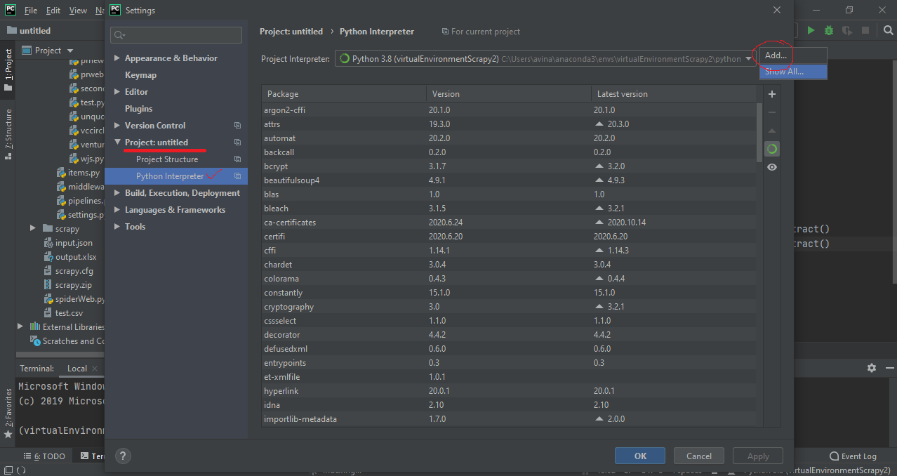

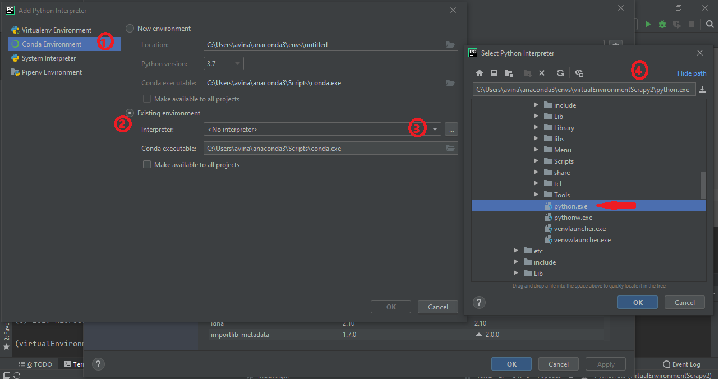

1. After setting the interpreter, restart Pycharm and it will set the Virtual environment on the terminal automatically.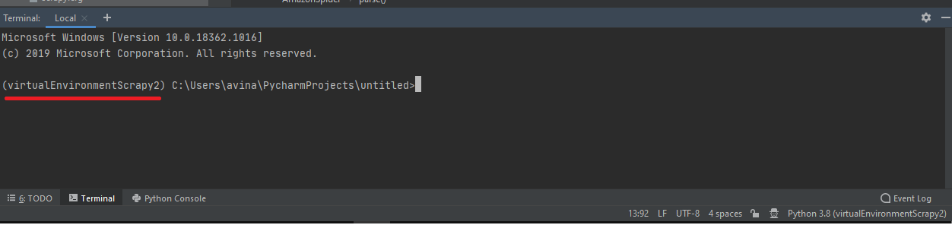
2. Run the crawler using spiderweb.py

Select the interpreter for the first run as below.

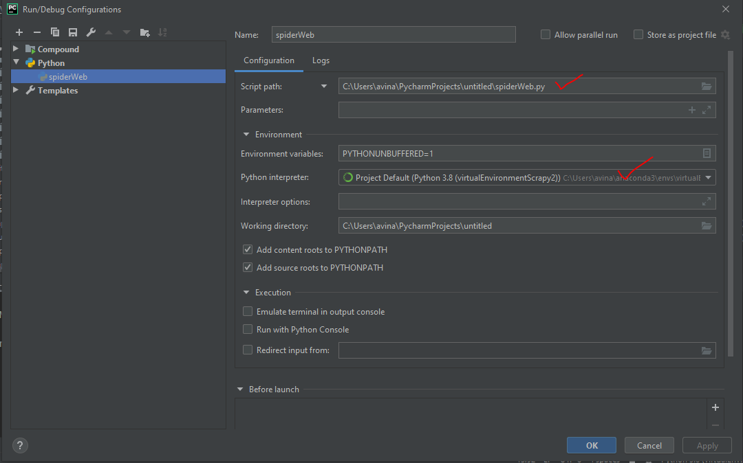

For any queries, please contact:

|  |  |
| --- | --- |
| |  | | --- | | Himali Saini [himali.saini@gmail.com](mailto:himali.saini@gmail.com) / Avinash Nagar <avinaash.naagar@gmail.com> | |